Global Visions of the Future of 3D Printing from China
A personal perspective with ten years of doing business and living in China
Gordon Styles

There is no point in me repeating information that is already widely available on the Internet and in the Wohlers Report. I went to China in 2005 with the express intention of setting up a rapid prototyping/3d printing company and have subsequently lived and worked in China for more than ten years. I therefore intend to give a very personal perspective on China’s future role in the global 3d printing market.

Star Prototype China Limited
I started my first 3d printing company, STYLES RPD, in the UK in 1993 and sold it in 2000. I started my second 3d printing company, Star Prototype, in Hong Kong/China in June 2005. With just a few thousand dollars in my pocket and a business plan under my arm I started STAR as a one-man band in a tiny bedroom in Dongguan.

The original plan was to raise venture capital, buy stereolithography machines and sell SL parts to the west, but this plan was soon scuppered when I was unable to raise venture capital. Apparently it is impossible to be successful in China if you cannot speak Chinese; have no friends in China; and no customers. I guess I have always enjoyed an impossible challenge.

Without any investment whatsoever STAR has now grown to be more than 200 people with sales of approximately EUR 13m. We have cash in the bank and are completely self-financing.

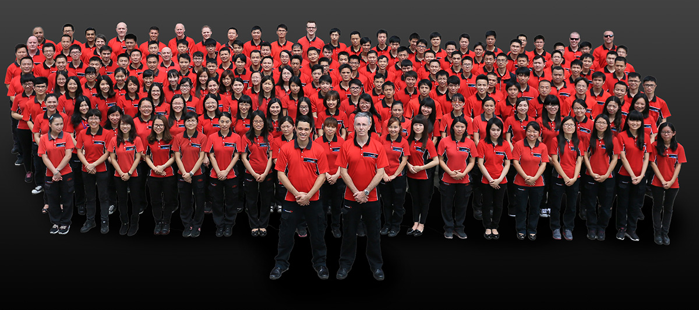
(Star Prototype in 2015)

At first I tried to sell SL and SLS parts to European and American customers, but there was a clear problem with delivery times. It takes typically 2 to 3 days to deliver a 3d printed part to the west and this proved to be too long for most customers – not to mention issues with customs declaration. In addition, we found that SL and SLS machines were being loaded very inefficiently and therefore the prices in China were already higher than their western counterparts. In the end, we realized that CNC machined prototypes in ABS were substantially lower in price, even though it is apparently a far more inefficient process than SL or SLS, but the customers loved the service and to this day the majority of the prototype parts we ship to the west are CNC machined.

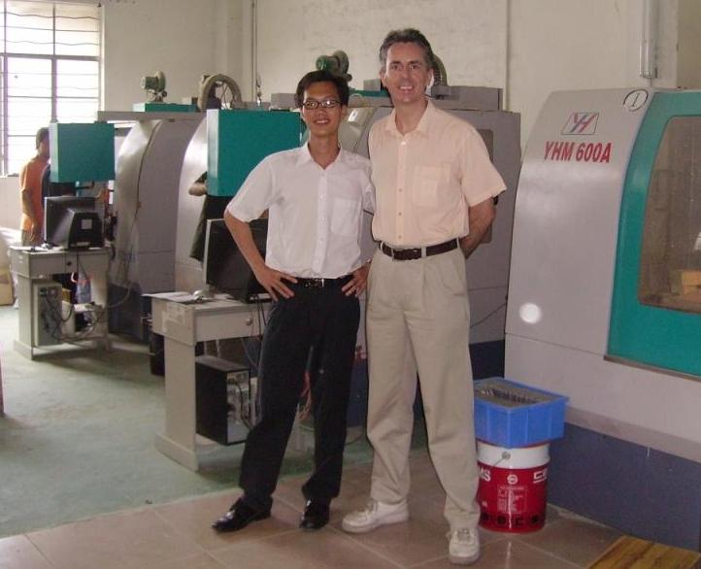

(James Li, STAR’s first employee, and Gordon Styles at a supplier, 2006. In the background were the staple model-milling CNC machines from YHM, each costing about EUR 10,000 at the time.)

Some History about 3D Printing Service Bureaux in China
Since the mid-nineties the Chinese local and national governments have set up government funded 3d printing bureaux all across China with the intention of seeding a 3d printing sector. Three good examples were Shenzhen YinHua (founded in 1996, now called KaiAo http://www.kaiao-rprt.com); Quick in Shenzhen Bao’an; and Hansun in Xiaolan/Zhongshan (founded in 1999). Over time these Government bureaux were subject to ‘buyouts’ that have left them ostensibly privately owned. In parallel in the early 2000’s a number of Hong Kong based and owned 3d printing bureaux were set up in Hong Kong.

Although all of these companies had SL or SLS and vacuum casting capabilities, most still gained most of their revenue from CNC machined prototypes.

Eventually the HK based bureaux realized that they had to move into Guangdong to lower their cost base and get close to the emerging customers inside China. By 2005 when I did an extensive market research study in China, in preparation for building my own rapid prototyping company, the market leaders inside China were either Government owned or Hong Kong owned. Now there are a myriad of Chinese owned 3d printing companies, most of which have “sprung out” of Government, HK, Taiwanese, or other foreign owned China based bureaux. STAR alone has been the birthing ground for 9 “spring out” bureaux. The majority of 3d printing bureaux are now Chinese owned.

Exportation of 3d printing
One would imagine that China would be able to export SL/SLS models at low cost, but the exportation of stand-alone SL and SLS parts from China is almost non-existent due to five key factors:

1. The parts are already too expensive, or at least there are no commercial savings once landed
2. The parts are generally of a substantially lower quality and tolerance than western parts
3. The delivery time to foreign countries is typically 2 to 3 days extra and customs can hold up parts (most exporters do not do their export documentation in accordance with Chinese and destination laws and this causes hold ups)
4. The materials are often found to be fake, low quality, or degraded (often not post cured in the case of SL parts)
5. CNC machined ABS prototypes are still cheaper than SL/SLS

Over the last five years we have noticed the emergence of Chinese owned 3d printing bureaux that mostly use locally produced SL and SLS machines. These companies are engaged in a vicious race to the bottom on pricing and quality. The local machines are typically one-third the price of western machines and are very similar to machines you would have seen in the late 1990’s in the west.
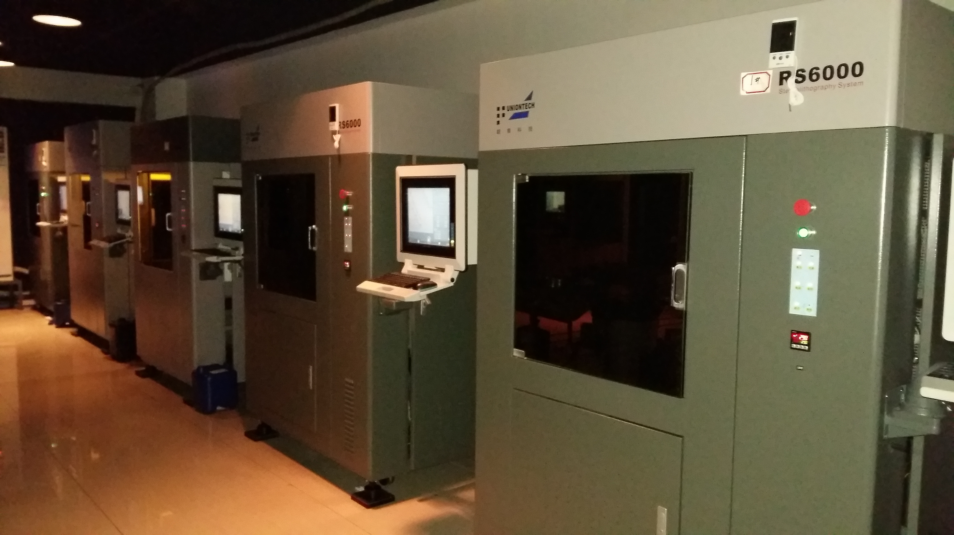

(A typical installation of China made SL machines in Dongguan – machine prices are typically 40% of western made machines.)

Image of 3D Printed parts in China
Since I first came to China to live and work in 2005, 3d printed parts sold in China have had a major image problem. They are viewed as being weak and poor quality in comparison to CNC machined ABS prototypes. Even to this day Chinese customers will insist on CNC machining rather than SL or SLS to ensure the quality and robustness of their prototypes. But critically the key reason why Chinese users have not switched from CNC to 3d printing is price. Even to this day I can buy or produce CNC machined ABS prototypes for substantially less than Chinese made 3d printed parts. How is this still possible?

Since 2005 I have noticed a general problem in the 3d printing service bureaux sector. Initially there were a number of grants available for large 3d printing machines, and in addition a number of Government owned machines were spirited away from their original location to other locations. This led to the cardboard cutout SL and SLS machines. I have seen a number of these. One would visit a bureau and they would claim to own a large frame 3d printer. You would be shown a room from the outside that had darkened glass and curtains on the inside. You could just catch a glimpse of a machine at the back of a dimly lit room. As an expert in the field I could immediately see that the machine was a cardboard replica. Of course our hosts would disagree. One time I got a look at one up close by just walking into the room when I was unaccompanied.

Also, some bureaux would buy a machine and find that they just couldn’t get enough work for it and when it came time to replace the laser they would opt to buy two CNC milling machines instead of one laser. To keep the grant aid they would need to demonstrate to the Government that the machine was still in working order. To do this they would fill the vat with a ‘fake’ liquid, a half built model on a plate, and do a laser show with a cheap ‘display laser’. I caught two suppliers doing this. One of those companies tried to sell me SL parts that had clearly been CNC machined out of ABS and sanded. The supplier fast retracted his claims when I told him that I had owned four SL machines of my own.

Even today the selection of a 3d printing company in China is fraught with problems:
- The machines are rarely maintained, assuming that the company concerned even owns the machine
- Parts are often built on locally made machines even when it is claimed that a western machine is being used, but even so,
- Most machines are rarely if ever calibrated
- Vat heaters are often burned out and not replaced. Not too great a problem in the heat of the summer, but in winter the resin is unusable
- The processing software for orientation and supports is almost always fake, which leads to scrambled data. Even when I have requested proof of legal ownership I will be handed fake documents. Local support software is either a copy of western software or extremely basic.
- The resin is almost always a fake local material if a branded material is claimed (this must be differentiated from a genuine local material sold as such – note that SL resins are not difficult to produce if the recipe is known)
- The Post Curing Apparatus (PCA) tubes are rarely replaced until they blow. The UV spectrum that cures SL resins will die out long before the lamp stops shining in the visible spectrum.

Even after ten years in China, and being a large purchaser of SL and SLS parts, I have only found one bureau that sticks to my rules. We guard that asset carefully. If you’re going to buy parts in China, you’d better keep very close to your supplier.

China going Global: The Values Mismatch?
I have worked in China for ten years and for much of that time I simply could not figure out why I had such an incongruent feeling when dealing with Chinese businesspeople and suppliers. Anyone who has worked in China knows that feeling. There was clearly a major mismatch between how Europeans and Americans do business and how the Chinese do. I am not in anyway claiming that one model of the world is better than the other, I am merely pointing out that there is a mismatch.

Recently I learned about the Clare Graves spiral system of values levels (see appendix 1) and had an epiphany. Just as individuals progress through the various values levels from birth to death, so countries have a values level mean. China’s mean is values level 3. The Chinese society is spread across values levels 2, 3, and 4 (with an emerging 5). But most western countries are spread across values levels 3, 4 and 5 (with an emerging 6). Business people going to China are strongly values level 5 business people, whereas Chinese businesspeople are mostly values level 3. (I must state that no level is better than any other level. If you live in a values level 3 environment, you had better get good at being values level 3 or you will probably not survive.) Much of what China is criticized for in business is related to this values level mismatch.

When operating a business in the UK I was solidly a values level 5 businessperson; but now operating in China I have had to adopt certain values level 3 principles so that I can operate effectively in China. For my customers I am values level 4 (operation of factory) and 5 (my entrepreneurial spirit), but in the factory I am VL3 (dealing with the employees on a day to day basis) and VL4 (the operation of the factory and disciplinary framework for VL3’s). Get with the values level that is appropriate or be eaten alive, and that goes for any environment on earth.

In terms of the 3d printing industry of China expanding out to the rest of the world the Chinese will face this values level mismatch problem most everywhere they will go.

China’s Global 3D Printing Advance

Will Chinese 3d printing machines flood the world market? I doubt that will happen for at least another ten years, patent issues not withstanding. The customer service ethos, language skills, and quality is simply not there yet. In 2005 I predicted incorrectly that the Chinese would switch very suddenly from CNC machining of prototypes to 3d printing. The switch had happened in the early and mid-nineties in American and Europe, and when it happened it was very sudden. (Between 1993, when I bought my first SLA-250, and 1995, the UK saw almost the entire CNC model-milling industry die. In the last ten years there has been a resurgence of CNC based prototyping, but it is still a niche market.) I expected the transition in China to have completed its transition by 2010, but even now in 2015 the switch is still happening, and it is very slow.

Government Investment – The Golden Shovel
The Chinese Government is reputed to be ploughing USD 1bn into 3d printing across academia, state-owned-enterprises, and private business; but recently the system of tax breaks for “highly encouraged industries” was abandoned completely. In fact, the entire system of categorizing companies and sectors as “discouraged; encouraged; and highly encouraged” was abandoned early in 2015. One can imagine this is due to economic growth pressures.

It is evident from my own experience with the local schools in China that they are all buying 3d printers. Children of friends of mine have shown me their 3d printed FDM parts. One kid in uniform walked passed a café I was sitting in recently carrying a 3d printer away from the school. The Government plan is to put a 3d printer into every one of their 400,000 elementary schools. That alone could be an investment of around USD 400m; although I imagine the cost of producing the tiny FDM style machines is collapsing as we speak.

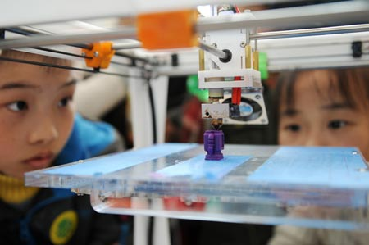

The Ministry of Industry and Information Technology (MIIT) is currently writing a plan called “The country’s additive manufacturing industry promotion plan for 2015-2016”. The top echelons of the Chinese Government are taking 3d printing very seriously. The industry is already breaking many boundaries with the printing of the largest metal parts for aerospace; the largest 3d printed buildings; and the cheapest printers on earth.

The intent exists to dominate the 3d printing space globally. My feeling is that the Chinese will utterly dominate the space eventually, but it will take decades to achieve. My guess is that they will start by carving out unusual niches such as low cost house building into the Middle East.

The Tsunami of VL5 Business People from China
One key thing must change before China can dominate business in the world: Chinese society must transition fully from a mean values level of 3 to a values level of 4. Do not underestimate this effect. This is the effect that, my humble opinion, the US Government does not appreciate. Once the Chinese reach a mean of values level 4, similar to other developed countries, it will mean that they have an emerging business class that is predominantly values level 5, and that is when they will utterly dominate business on planet earth. Any country that ignores this key transitional issue will be caught with their pants down. The days of the obvious values level mismatches in deals such as Alibaba/Yahoo, and WaHaHa/Danone, that went so disastrously wrong, will be a thing of the past and Chinese values level 5 businesspeople will dominate global business.

Summary
In summary I believe that the Chinese will come to utterly dominate the 3d printing space, but I think it will take decades to achieve, maybe a whole generation. As the Chinese say – man man lai 慢慢来 – which would be the equivalent of ‘slowly slowly catchy monkey’ in English. Frankly you could map this approach on to the entire ‘emerging China’ issue.

My first employee and former business partner James Li explained to me that the ‘way’ of the Chinese is to be humble and hide your power as it grows. If your house grows taller, build taller walls. One day your power becomes so apparent that all around you merely defer to you in awe and will not challenge you. If you ever use your power in an aggressive manner, you allow your enemy (and he means your competition) to assess you and learn how to destroy you. This is the traditional Chinese approach to everything. The good news is that the Chinese hate to use their power and prefer to negotiate a peaceful outcome. In a multipolar world this might be refreshing.

One of China’s key strengths is that the Government acts as the largest venture capitalist on Earth funding anything that looks promising with sums of money that make most global investors blush. Western Governments need to take note if they expect their domestic manufacturers to compete with this approach.

To suggest in the 1960’s or 1970’s that one day the Japanese would make a quality product in any engineering field would have been considered ludicrous to all but a few western engineers in the know; and yet today they are mentioned in the same breath as Germany and Switzerland when choosing a high-tech CNC machine tool. So it will come to pass in a few short decades that Chinese products will be given high status.

Appendix 1 – Clare Graves Values Levels Summary

Note: There is no values level that is better than any other values level. They are all contextual. If you are thrown into a forest with just your close family with no hope of finding civilization, you had better learn to operate at Values Level 1 or die.

All modern humans operate across multiple values levels depending upon environment and context. For example I was tested and my values levels were:
VL1 – closed out
VL2 – closed out
VL3 – moderate
VL4 – above moderate
VL5 – high
VL6 – moderate and still emerging
VL7 – emerging
VL8 – not reached

My mean could be seen as VL5, but able to operate across 3, 4, 5, and 6 seamlessly. Most people are having a narrower bandwidth than me. Working in China has required me to re-open VL3 to survive in China.

[The notes below are my personal observations and from work by Adrianna James of The Tad James Company. I am a certified NLP Master Practitioner – the study of Clare Graves’ spiral values levels is now adopted as part of the NLP Master Practitioner course. These notes are for guidance only.]

Values Level 1 - Survival
Basic survival in small bands; hunting gathering; instinctive; uses deep brain programs; distinct self is barely awakened; lives much as other animals; minimal impact on environment; concerns about finding food, shelter, and mating are dominant.

Emerged 100,000 years ago, is merely 0.1% of modern global adult population and has about 0% of power. (Percentages add up to 111.2% and 107% respectively in source data for all currently defined 8 values levels, and act only as a guide.)

In the context of a modern human this level is observed in babies and toddlers. In most cultures this is only observed in tramps, long-term homeless and long-term sick.

Values Level 2 – A Clannish “Us”
Small village mentality; magical enchanted village; obey the desires of mystical spirits; allegiance to elders, custom and clan; preservation of sacred places, objects and rituals; bond together to endure and find safety; seek humanity with natures power; shamanism; sacrificing beings to the spirits; dead ancestor worship. Hunting and gathering made more efficient through specialization in the tribe.

Emerged about 50,000 years ago, represents about 10% of global adult population today, and holds about 1% of power.

In the context of a modern human this level is observed from being a small child until puberty.

In the context of China, many people who grew up in villages carry these values quite strongly, hence the strong adherence to the rituals of Chinese New Year and other festivals. (Remember: there is no right or wrong – there just “is”.)

Values Level 3 – My Powerful “Self”
Every man for himself; dog eat dog world; kill the competition – literally in some cases; rebelling against level 2 values; expression of self, but to hell with others; escape domination by others or nature; avoid shame, feel no guilt, fight to get respect; gratify impulses & senses immediately; fight to gain control at any cost; not constrained by consequences; low self-esteem.

Emerged about 10,000 years ago, represents about 20% of global adult population today, and holds about 5% of power.

In the context of the modern human this is often observed around puberty. Teenagers rebelling against family control. If a level 3 does not transition to level 4 they are often seen as adults who believe that life/the government/the world owes them something and believe that welfare is their right. Nothing is ever their fault, and the world is against them. Most gangs start with VL3, but usually transition to VL4 to control the gang members.

In the context of China: many Chinese business people operate on values level 3. It can take decades in business for them to transition through level 4 to level 5, but transitioning they are.

Values Level 4 – A Righteous “Us”
Obedience and deference to a book or a system of rules. The book can be religious, business, or legal in nature. Sacrifice self to the betterment of the majority. Monotheistic religions are defined by level 4 values. My reward is in heaven or later in life. Reverence to a higher authority. Seek to find meaning and purpose in life; sacrifice self to the truth; bringing of order; stability and future reward; control of impulsivity through guilt; enforce principles of rightful living; divine plans put people in the proper places. All of the ‘isms’ of capitalism, communism, socialism reside here. Democracy; benevolence; autocracy; moralistic; prescriptive; resistance to change; the rules are black and white and must be obeyed.

Emerged about 5,000 years ago, represents about 40% of the world’s modern adult population, and holds about 30% of power.

In the context of modern humans this is seen when people finally accept the rules of the higher authority, whatever or whomever that may be. These people are considered to make the best employees and are very loyal. These people are widely considered to be the backbone of “society” and the workforce. When governments talk of “hard working families” they are referring to VL4 led families.

The very nature of the Communist Party is values level 4, as is that of most governments and bureaucracies around the world. The challenge for the Chinese Government over the last half century has been to govern and develop a predominantly VL2 country as it transitioned through VL3 and VL4, and endeavor to engender a VL5 entrepreneurial business and innovation spirit amongst its business leaders.

Values Level 5 – My Strategic “Self”
If it ain’t broke – then break it and make it even better; strive for autonomy and independence; seek out the good life and abundance; bring about progress through the best solutions; enhance living for the many through technology; play to win and enjoy competition; learn through tried and true experience; entrepreneurial spirit; the power of ideas; it’s just business; the ends justify the means; invention. What is the point of God?; atheism emerges.

Emerged around 300 years ago, represents about 30% of modern adults, and hold about 50% of power.

In the context of modern humans this is the business, innovation, and entrepreneurial values level. Most business people in developed economies are VL5 business people.

In the context of China, there are a relatively small number of VL5 business people today – most are doing VL3 business. They are happy to compete, treat their workers very well, and look to long-term success by delivering good quality and service. This is the emerging business class of China that the rest of the world needs to take notice of. It may be a small minority today, but within a generation it will be the norm.

Values Level 6 – Our Communitarian “Us”
Liberate humans from greed and dogma; care for the holistic environment; explore the inner being of self/others; promote a sense of community and unity; share society’s resources among all; reach decisions through consensus; refresh spirituality and bring harmony; softness; tasteful wealth; sensitivity; respectability; personality; social class distinctions unclear; rule by the majority (but not democracy in the current context); do anything not to be rejected.

Emerged around 150 years ago; represents about10% of the modern world population, and holds about 15% of power.

This is seen as the environmental, green, hippy values system. That said, most people that appear to be VL6 (particularly the hippies of the 60’s) are in fact VL4 reaching out to VL6. This is referred to as a 6 inside of 4 effect.

Vales Level 7 and 8 not relevant to this discussion – see below.

Images below downloaded from the web, credits reside within the images.

